Below are a couple pieces of general information, then page-specific details needed to progress through particular parts of the game.

**General Information**

The game’s title is Latin for “Let there be darkness,” in contrast to the university’s motto which is Latin for “Let there be light.”

uHall is the name of the original campus building constructed when the university was first founded. It is situated between the coulees (hills) overlooking the Oldman River.

**Initiation**

On the outside of the Library Information Network Centre building is a sign that reads “I am still learning.”

**Architect**

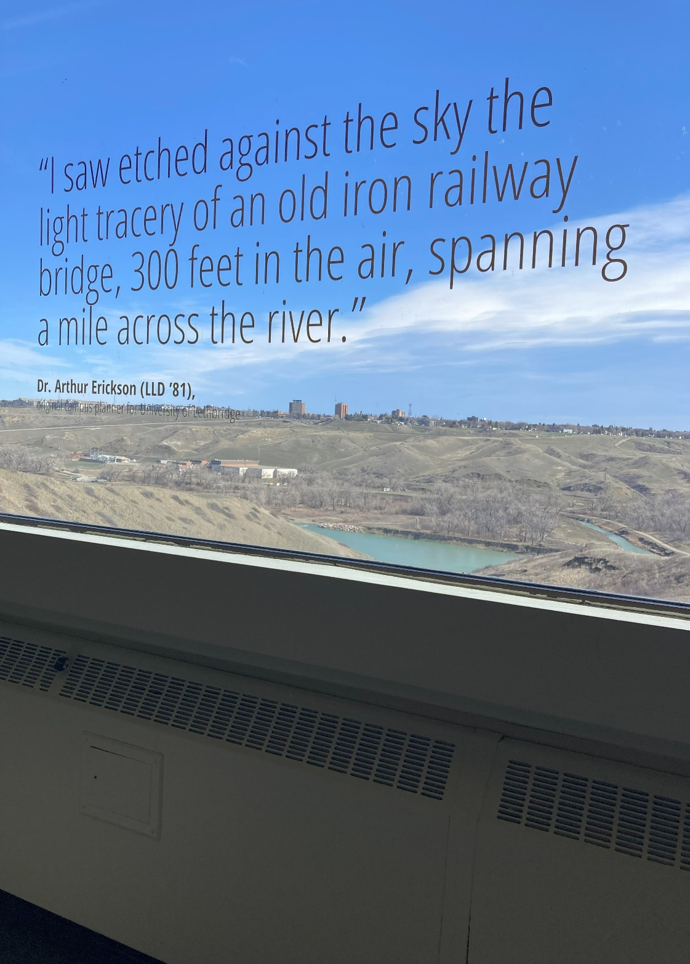uHall is separated into blocks A through E. Between C block and D block, there is a quote from the architect who designed the building, Arthur Erickson, affixed to the window:

**Coy Site**

Running parallel to the main stairwell in the Fine Arts Wing is another set of stairs known as the “secret stairs,” which possesses a small landing between the eighth and ninth floors where students occasionally conduct shenanigans. Players who go to this location find a QR code that leads them to the page “../monster/logo.html”

**Below**

There is a tunnel connecting the Students’ Union building to the LINC building. Players who go to this location find a QR code that leads them to the page “../tunnel/4-words.html”

**4 Words**

As an easter egg, selecting E-V-I-L leads to another page within the game.

**Goodbye**

On the top of one of the coulees bookending the campus is a sculpture of a bison. Or of a buffalo. It depends on whom you ask. Players who make the trek out to it find a ziptie with letter beads on it spelling out FEAR.

**Aperture**

There is a sculpture in the university bus loop known as The Aperture.